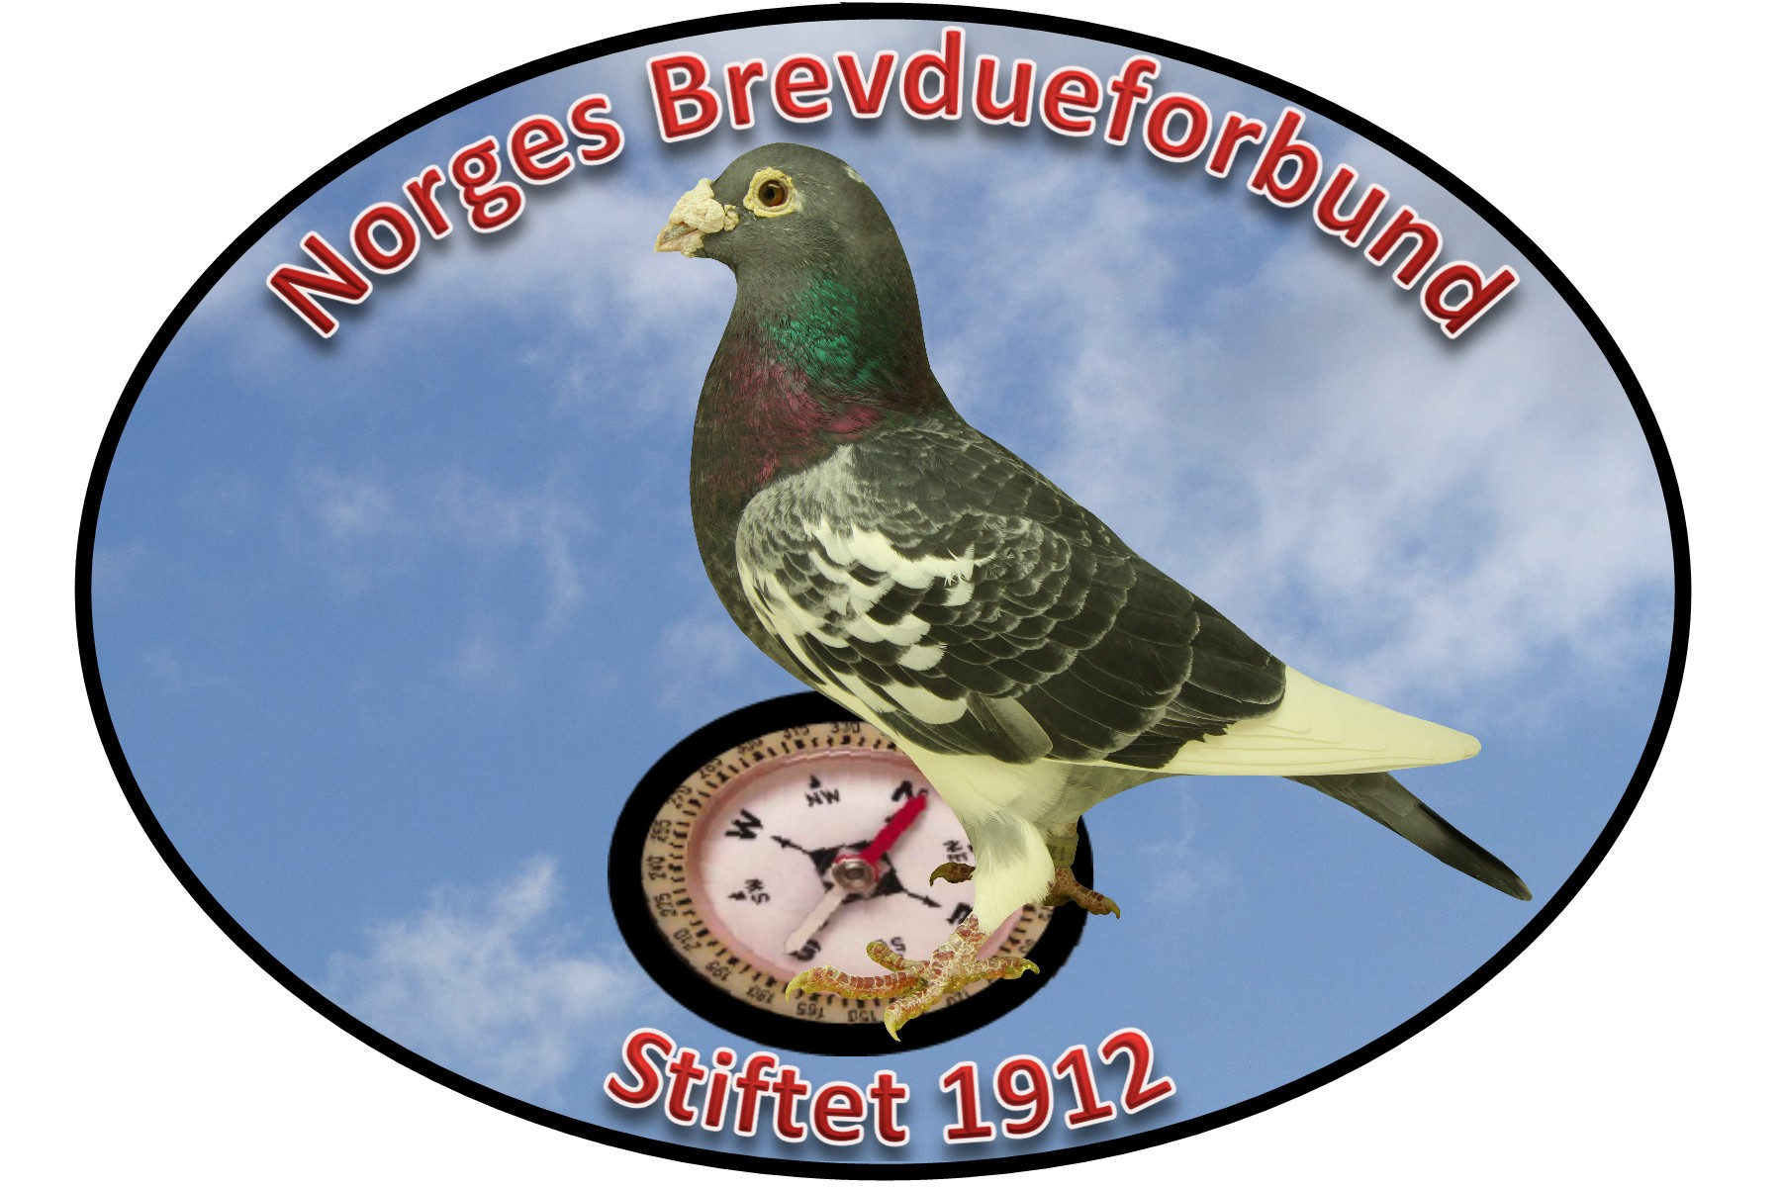
Norges Brevdueforbund
The Norwegian Racing Pigeon Federation

FCI Europamesterskap 2018
FCI European Championship 2018

Eiendomsbevis - Ownership card
Duens ringnummer/ ringnumber
Oppdretter/ Breeder
Adresse/ Adress
Postnr. - sted / postal code & city
Land/ Country

Stamtavle - Pedigree
A (Father) | A (Grand Father) | A (Great grand-father)
 |  | U (Great grand-mother)
 | U (Grand Mother) | A (Great grand-father)
 |  | U (Great grand-mother)
U (Mother) | A (Grand Father) | A (Great grand-father)
 |  | U (Great grand-mother)
 | U (Grand Mother) | A (Great grand-father)
 |  | U (Great grand-mother)

Eiendomsretten av denne dua overføres til arrangøren av FCI Verdensmesterskapet 2018, Det Portugisiske Brevdueforbund.
We hereby transfer the ownership of this pigeon to the organizer of the 2018 FCI World Championship, the Portuguese Pigeon Fanciers Federation.

Underskrift eier/
Signature from breeder:__________________________________________________________

